**EXAM REVISION WACE 2014 Question 32 (13 marks)**

1. Propose a hypothesis for the experiment. (1 mark)

|  |  |
| --- | --- |
| **Description** | **Marks** |
| Statement including independent and dependent variable/nil hypothesis/null hypothesis (e.g. Increased exercise will increase lung capacity) | 1 |
| **Total** | **1** |

1. Identify
   1. the independent variable. (1 mark)

|  |  |
| --- | --- |
| **Description** | **Marks** |
| Amount of exercise |  |
| **Total** | **1** |

* 1. the dependent variable. (1mark)

|  |  |
| --- | --- |
| **Description** | **Marks** |
| Lung capacity |  |
| **Total** | **1** |

* 1. **two** variables that were controlled in the experiment. (2 marks)

|  |  |
| --- | --- |
| **Description** | **Marks** |
| Any 2 of: | 1–2 |
| * Gender of participants * Age range of participants * Timing of recording of data/all participants measured weekly * Method of recording data/all participants used spirometer |
| **Total** | **2** |

1. If the researchers were aiming to improve the reliability of the experiment, suggest **one**

change they could make to the experiment. (1 mark)

|  |  |
| --- | --- |
| **Description** | **Marks** |
| Multiple trials/larger sample size |  |
| **Total** | **1** |

1. On the grid below, plot the data as a graph in the most appropriate style. (5 marks)

|  |  |
| --- | --- |
| **Description** | **Marks** |
| Correctly plots points and joins points to form a line/curve | 1 |
| Uses a suitable scale | 1 |
| Title appropriate with both variables included | 1 |
| Key for lines/identify lines | 1 |
| Labelling of axes with correct name and unit | 1 |
| **Total** | **5** |

**Lung capacity changes in two exercising groups (over a six week trial)**

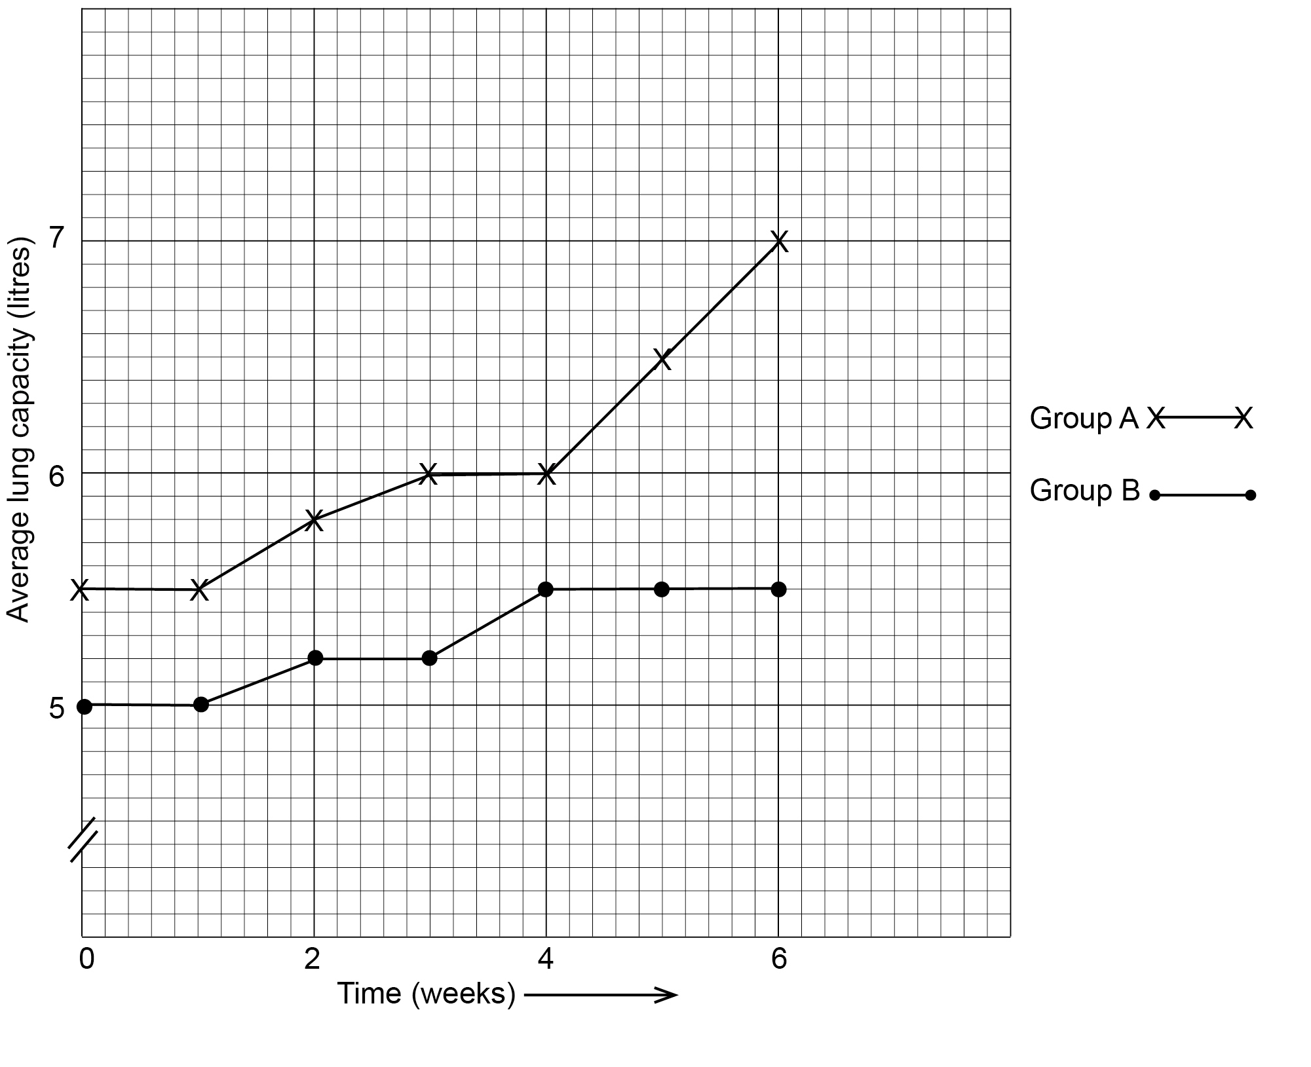

1. Further experiments were undertaken on different factors affecting lung capacity. What effect would you expect the lifestyle choice of smoking cigarettes would have on lung capacity? Justify your answer. (2 marks)

|  |  |
| --- | --- |
| **Description** | **Marks** |
| Reduced/lower lung capacity | 1 |
| Lung function is decreased due to tar/congestion/emphysema/cancer/damage alveoli | 1 |
| **Total** | **2** |

**Question 36 (16 marks)**

1. Write a suitable hypothesis for the study. (1 mark)

|  |  |
| --- | --- |
| **Description** | **Marks** |
| Any statement linking healthy diet to changes in blood cholesterol levels  E.g.: Adopting a healthy diet will reduce blood cholesterol levels | 1 |
| **Total** | **1** |

1. In this study, identify the
   1. independent variable. (1 mark)

|  |  |
| --- | --- |
| **Description** | **Marks** |
| Healthy diet | 1 |
| **Total** | **1** |

* 1. dependent variable. (1 mark)

|  |  |
| --- | --- |
| **Description** | **Marks** |
| Blood cholesterol levels | 1 |
| **Total** | **1** |

1. State the name given to Group A and state the purpose of using this group. (2 marks)

|  |  |
| --- | --- |
| **Description** | **Marks** |
| Control (group) | 1 |
| Compare results with the other group | 1 |
| **Total** | **2** |

1. On the grid provided, plot the data as a graph in the most appropriate style.

(5 marks)

If you wish to make a second attempt at the graph, the grid is repeated at the end of this Question/Answer Booklet. Indicate clearly on this page if you have used the second grid and cancel the working on the grid on this page.

|  |  |
| --- | --- |
| **Description** | **Marks** |
|  |  |
| Correctly plots points and joins points to form a line/ curve | 1 |
| Labelling of axes with correct name and unit | 1 |
| Uses a suitable scale | 1 |
| Title appropriate with both variables included | 1 |
| Key for lines/ identify lines | 1 |
| **Total** | **5** |

1. The researcher stated that Group B adopted a healthy diet. This could mean several changes to what an individual does or does not consume during a day.
   1. List **three** healthy diet choices. (3 marks)

|  |  |
| --- | --- |
| **Description** | **Marks** |
| Low in fat/ low in saturated fat/ eating reduced fat dairy | 1–3 |
| Low in salt |
| Low in sugar/ low in carbohydrate/ low in high GI foods |
| High in protein/ eating lean meats |
| High in vitamins/ high in minerals/ high in vitamin B/ high in calcium |
| High in fruits and vegetables/ high in green leafy vegetables |
| High in wholegrain cereals/ eating low GI foods/ high in fibre |
| Increased water consumption |
| Smaller portions, more regularly |
| Less processed food more organic |
| **Total** | **3** |

* 1. Explain why it was important for the researcher to test only one of the possible dietary changes and not many at the same time during the study. (1 mark)

|  |  |
| --- | --- |
| **Description** | **Marks** |
| With many, it would be impossible to know which diet change caused the results | 1 |
| **Total** | **1** |

* 1. Suggest **two** other lifestyle choices, besides diet, that the researcher might also recommend for healthy living. (2 marks)

|  |  |
| --- | --- |
| **Description** | **Marks** |
| Daily physical activity/ exercise | 1–2 |
| Reduce stress |
| Low/ no alcohol consumption |
| No smoking |
| No illicit drugs/ excessive use of prescription drugs |
| **Total** | **2** |